To-do:
- Ask Ed for:
  - Final front page image.
  - Favicon
  - PRESSUR logo font

Done:
- Html outline

Notes:
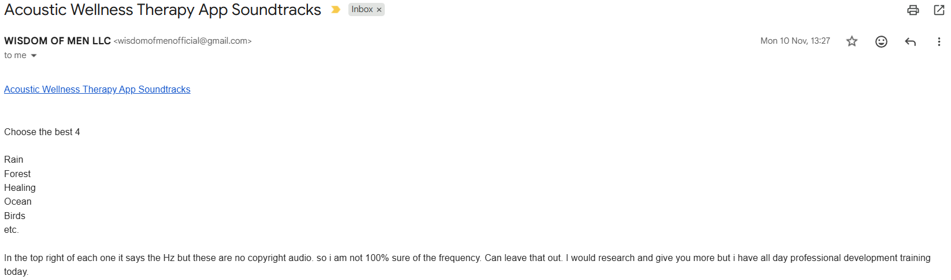
AudioMotion
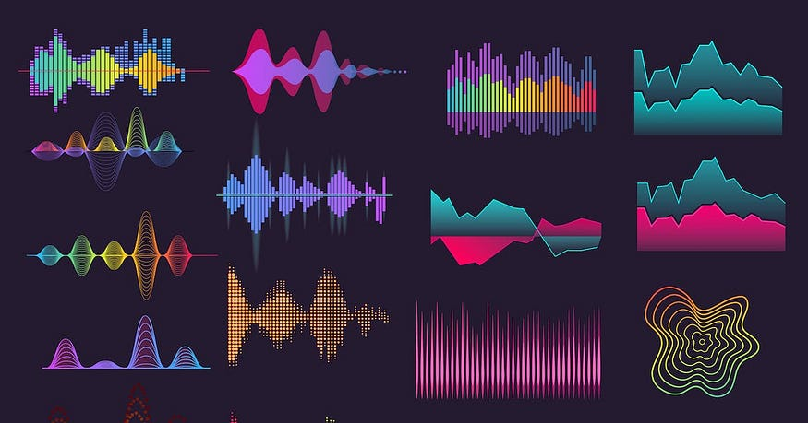

OUTLINE
I want to focus on an MVP, namely: 4 pages:
- simple login page - with pin code 4 numbers or biometrics (once it's a PWA), does not have to be secure! in here will only be stored an account name, heartrate and favourites.
- category page - where users select the session they want from a small card grid that outlines some benefits
- Session page - where users see 3 cards:
  - The category as a title, an audio visualization/animation (like breathing animation), progress bar for their session, progress bar for the song/audio they're listing to (incl. forward/backward and pause button) and a heart rate monitor.
  - 'Session Duration' card with buttons and a slider for selecting session duration and favouriting. As well as a tracker for some account statistics, like total sessions, total time in the chamber and heartrate over time as well as some clever way to show the selected category (maybe coloring the graph datapoints)
  - 'Session Options' card with 2 toggles, 1 for biometric adaptation, and another for PRESSUR sync. Both are placeholders in the MVP and won't be hooked up till later. This card also gives the option to download the song.
- An account (overlay) page - This has detailed analytics overlayed over a heart icon, as well as an overview of favourited songs/sessions etc. The exact shape will be decided later, it can be a placeholder for now. I mentioned "overlay" because I want users to be able to look at their analytics while the music/session keeps going.

Next:
I want to change the naming convention for tracks to get prettier titles:
"
<script>
document.addEventListener('DOMContentLoaded', () => {
fetch('library.json')
.then(response => response.json())
.then(data => renderCategories(data))
.catch(error => console.error('Error loading library:', error));
const user = Session.getCurrentUser();
if (user) {
document.getElementById('menuWelcome').textContent = `Welcome, ${user.name}`;
}
});

function renderCategories(library) {
const container = document.getElementById('categories-container');
container.innerHTML = ''; // Clear spinner

// Map through keys (healing, meditation, etc.)
Object.keys(library).forEach((key, index) => {
const cat = library[key];
const accordionId = `acc-${index}`;

const cardHtml = `
<div class="col">
<div class="category-card">
<div class="accordion" id="parent-${accordionId}">
<div class="accordion-item">
<h2 class="accordion-header">
<button class="accordion-button collapsed p-4" type="button" data-bs-toggle="collapse" data-bs-target="#collapse-${accordionId}">
<div class="d-flex align-items-center w-100">
<i class="bi ${cat.icon} fs-1 me-4 text-info"></i>
<div class="flex-grow-1 text-start">
<div class="d-flex justify-content-between align-items-center mb-1">
<span class="text-uppercase fw-bold ls-1">${key}</span>
<span class="hz-badge text-muted">${cat.hz} Hz</span>
</div>
<p class="small text-light m-0 pe-3">${cat.description}</p>
</div>
</div>
</button>
</h2>
<div id="collapse-${accordionId}" class="accordion-collapse collapse" data-bs-parent="#parent-${accordionId}">
<div class="accordion-body p-0">
${cat.tracks.map(track => renderTrackItem(track, key)).join('')}
</div>
</div>
</div>
</div>
</div>
</div>
`;
container.innerHTML += cardHtml;
});
}

function renderTrackItem(filename, category) {
// Clean up filename for display: "1.healing-forest-compr.mp3" -> "Healing Forest"
const displayTitle = filename
.replace(/^\d+\./, '') // remove leading numbers and dot
.replace(/-compr\.mp3$/, '') // remove -compr.mp3
.replace(/-/g, ' ') // replace dashes with spaces
.replace(/\b\w/g, l => l.toUpperCase()); // Capitalize words

// URL safe path for the link
const filePath = encodeURIComponent(`assets/audio/${filename}`);

return `
<div class="track-item">
<div class="d-flex align-items-center">
<i class="bi bi-play-fill fs-4 me-3 text-white-50"></i>
<span>${displayTitle}</span>
</div>
<div class="d-flex align-items-center">
<button class="btn btn-link text-white-50 p-0 me-3">
<i class="bi bi-star"></i>
</button>
<a href="session.html?track=${filePath}&cat=${category}" class="btn btn-sm btn-gradient px-3 rounded-pill">
Start
</a>
</div>
</div>
`;
}
</script>
"

